MAMF Journal

Place an advertisement in the Journal and support the MAMF.

Advertising allows you and/or your company to:
- Promote your organization in an industry keepsake.
- Shows your support of the industry and the MAMF.

Attendees of the MAMF Annual Awards Celebration, members of the MAMF, and Journal Sponsors will each receive a copy of the Journal.

Ad Size / Pricing – all pages in color

- Full Page (8 ½”x 11”) $250
- Inside Back Cover $350
- Inside Front Cover $350
- Back Cover $400
- Half Page $175
- Quarter Page $75

All artwork must be submitted in PDF format and will appear in color in the Journal. Journal will be 8 ½” x 11”. Deadline for placing ad is January 15, 2021.

Company Name _______________________________________________________________________

Contact Person ________________________________________________________________________

Address________________________City__________________State__________Zip Code_______

Phone________________________ Email_________________________

Payment Information
Enclosed is my check, made payable to the MAMF for $________________.
Please charge my credit card for the amount of $______________________.

Mastercard _____ Visa_____ American Express______

Name on Card______________________________Credit Card Number____________________
Expiration Date______________________ Billing Zip Code______________
Signature___________________________________________

Contact: Donna-Jean Plante, MAMF
P.O. Box 185
Congers, NY 10920
Phone: 914.522.6564 Email: admin@metalfinishers.org

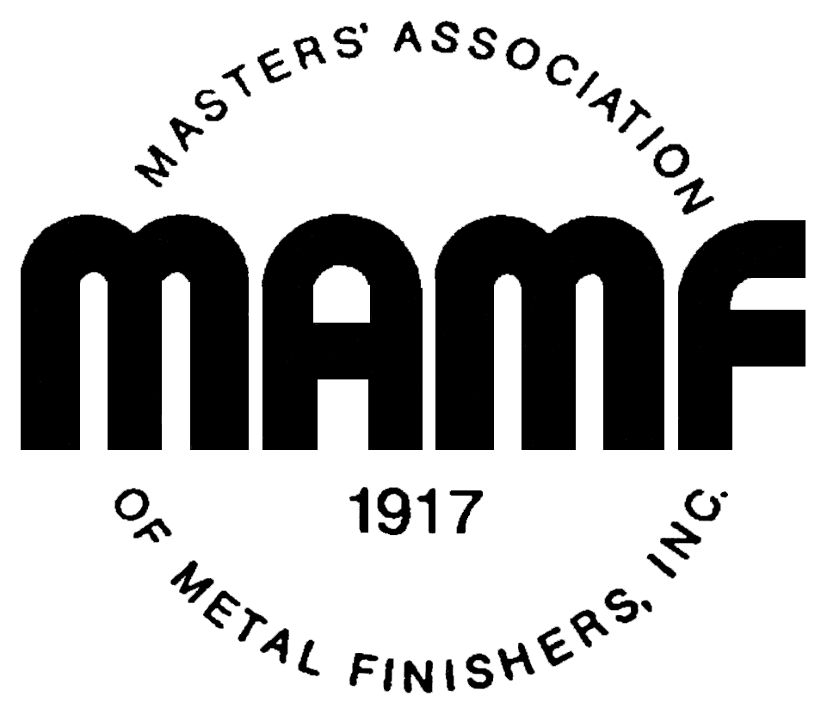

Dear Supporter:

For over 100 years the Masters’ Association of Metal Finishers (MAMF) has been the driving force behind the metal finishing industry in the Northeast; promoting and protecting the interests of our industry, its workers and the environment. MAMF is one of the larger affiliates of the NASF, a national organization of metal finishing companies, suppliers, and individual members based in Washington D.C.

The MAMF has been in the forefront of promoting the general welfare of the metal finishing industry through its advocacy work and its dedication to the promotion of the positive work that is being done in the industry. The MAMF has developed strong relationships with federal, state, and local regulatory and environmental agencies that foster the compliance and education of its members. We strongly believe that protection of the environment, the public at large, and the welfare of our work force are, and must continue to be, primary objectives of our Association and its members. We support all equitable and reasonable regulations designed to achieve those goals and we condemn those who would purposely evade those regulations. With your support of our Journal we can continue to provide the information and services our members have expected from our organization.

The Masters’ Association of Metal Finishers is producing a Journal to coincide with their annual 2021 Annual Awards Celebration. Please consider purchasing an ad in our keepsake Journal. This keepsake will contain detailed information about each of members of the MAMF. Enclosed is a form to purchase an ad in the Journal. There are a limited number of ad pages in the Journal so please be sure to reserve your ad space as soon as possible. Thank you in advance for your consideration and support of the MAMF.

On behalf of the MAMF, I want to thank you in advance for your continued support.

Very truly yours,

Jeff Lawrence
President, MAMF

